LRF COVID 19

SOUTH RIBBLE Local Prevention Zone

DRAFT Framework for local plan

Dated 16th September 2020

- Assessment

LOCATION | South Ribble Borough Council
DYNAMIC RISK ASSESMENT | SEE ANNEX B
DATE FRAMEWORK LAST REVIEWED | 05.10.20

- Situation

Using indices of positive cases in pillar one and pillar two, positivity rates and exceedance reports it is apparent that the incidence of coronavirus is increasing at an alarming rate across Lancashire in general, and the number of cases of coronavirus per 100,000 people is increasing in South Ribble with cases having increased to 139.3 per 100,000 (04.10.20). Over the last 7 days there has been an increase of testing to 185.5 per 1000,000 population and the percentage of people testing positive is 10.7% which is increasing. There have been three recorded community outbreaks and 154 confirmed cases within the last 7 days.

Currently South Ribble is RAG rated Red. A RED rating is given if the threshold is exceeded for two or more of the 14 most recent days regardless of the magnitude of the exceedances, OR if the observed cases per 100 tests is greater than the forecast mean value for 12 of the 14 most recent days. An AMBER rating is given if the threshold is exceeded for only one of the 14 most recent days, OR if the observed cases per 100 tests is greater than the forecast mean value for 10 or more of the 14 most recent days. Otherwise a GREEN rating is

The epidemiological report indicates that cases are reported in a widespread number of wards in South Ribble with Farington, St Ambrose, Broadfield, Earnshaw Bridge, Howick and Priory being the most affected areas within the last 7 days.

The Council is now subject to national interventions which came into force on the 22nd September and introduced the following Regulations:

- That interhousehold mixing in private dwellings and gardens is prohibited
- That the hospitality sector (food and drink) be limited to table service only
- That the night time economy be subject to closing between 22:00 and 05:00

Guidance:

- Residents are advised to only use public transport for essential purposes, such as travelling to school or work
- Residents are advised against attending amateur and semi-professional sporting events as spectators

- Purpose of this plan

The aim of this plan is to reduce the rates of COVID-19 in South Ribble and ensure continued compliance by both businesses and the members of the public with Covid-safe regulations in order to maintain low rates of infection.

Key messages around the need for the community to continue to understand we all have a part to play to help tackle the virus. Messages to our community will continue:

• stay at home as much as possible
• limit contact with other people – comply with the rule of 6
• keep your distance from people not in your household (2 metres apart where possible)
• wash your hands regularly
• Do not leave home if you or anyone in your household has symptoms.

Proactive working with our Business community is key to keeping the rates low in South Ribble. An education campaign has been undertaken with our local businesses and to ensure businesses will not become complacent regular visits are continuing to be made to all high-risk businesses on the district. More high-risk businesses have opened over the past weeks including leisure operations, gyms and facial beauty and these businesses are being targeted. Messaging to businesses have been quite confusing especially for small businesses and we will help them understand their duty to ensure they are maintaining good standards of compliance in their premises.

South Ribble has developed a community hub which has supported our vulnerable residents to stay at home and limit contact with other people. The hub will continue to support our residents during this next phase of the pandemic.

- What impacts do we want to have?

- To reduce sources and rates of transmission
- To promote symptomatic testing
- To educate and reassure the local population with general messaging
- To educate targeted groups
- To improve case finding with daily data
- To bring about more timely contact tracing
- To increase asymptomatic testing
- To restrict mass gatherings

- Where is this happening?

As of the 5th October geographically the cases are occurring in a wide spread number of wards with Farington, and Howick and Priory being the most affected wards. It is not possible to pin point the contributing factors to these cases, but Community transmission is the most likely cause.

Currently rates in South Ribble are increasing at an alarming rate and the area is now subject to national interventions. Work is ongoing to target the high-risk community and business settings. These include education campaigns in houses of multiple occupation, shelters, homeless accommodation and in businesses in the food, beauty and leisure sector.

In addition, South Ribble Borough Council has been working to bring about more timely contact tracing. The team is currently working with our partners to look at the feasibility of South Ribble Borough Council undertaking an element of contact tracing. In principle if the national tracing team are unable to contact a resident in South Ribble within 24 hours the case will be referred to the Council who will contact the resident via phone, email, SMS message and visit with all of the available contact details we have to undertake the contact tracing.

- Community Support

Community support and protecting community cohesion is crucial for the success of this plan, as it requires behaviour change and awareness of how cultural norms affect infection rates. We have an existing community engagement network to enable us to communicate with key community contacts, elected members, and stakeholders in the relevant wards, as well as pan-borough representative groups, to inform them of the situation, and provide reassurance. We are engaging with our community via social media and specifically raising awareness in high risk settings.

We will discuss the messages with our community to ensure any proposed measures are supported by the community. We will link in with our BAME groups to ensure messages are sent on a risk-based approach.

Mobilising a whole systems approach will be the most effective means of ensuring that the borough can reduce rates of community transmission which involves working with our partners in LCC, local NHS and the police.

- Dynamic Risk Assessment

We are adopting a dynamic risk assessment framework, based on our intelligence and evidence base to inform the local plan. We intend to use this as a guide to review the situation across our localities on a regular basis. We will adapt this as national policy evolves.

The current Dynamic Risk Assessment Status for South Ribble is rated RED as very local community transmission has been identified and additional national intervention and public appeal is needed. As can be seen in Annex B the suggested measures are cumulative and sequential. The measures are proportional to risk of impact to community. Annex D details the Battle Rhythm for Triggering Task Force Activity and Declaring a Local Prevention Zone. The action plan set out below will support the council in preparing should the situation worsen and the rating change.

We are reviewing the situation and actions daily on the SCG pacesetter based on the test positivity 1.7 %, positive per hundred thousand, effectiveness of NHS test and trace service, and all the local intelligence we collect. Our ongoing monitoring and public health professional assessment may trigger more interventions as appropriate and will also be used to deescalate measures. Other indicators will be used such as:
- Trend on small areas (MSOAs, LSOAs) worsening
- NHS 111 triage
- Hospital admissions
- Outbreak surveillance
- Soft Intelligence e.g. changes to testing/local behavioural intelligence

- Plan and Course of Actions

The plan and course of action in South Ribble is to ensure the rates of community transmission are low by focusing on community engagement, to ensure national and local guidance is followed; promoting uptake of testing; enhanced inspection support; monitoring.

- Lancashire Resilience Forum (LRF) Warning and Informing Cell will disseminate key messages across the borough and county, continuing to provide the national information on preventative measures that the public can take to reduce the transmission of the virus, signposting testing opportunities and advising on the action needed after a positive test result in order to prevent further transmission. These key messages will be disseminated by South Ribble Borough Council via social media and main stream media and will also be targeted at our vulnerable to the virus in our community.

- The South Ribble Borough Council’s Environmental Health and Communities team have been conducting inspections of priority settings, to provide engagement and education on infection prevention, ‘Covid secure’ best practice and, where necessary, enforcement action, to reduce the opportunities for transmission of the virus. Additional recruitment has now taken place and further resources have been transferred into the Environmental Health Team.

- Recognising the lessons learned from other areas, and that proportionate interventions should be led by intelligence or evidence, the Director of Public Health for Lancashire, on behalf of the LRF, has made representations to the Department of Health and Social Care and now has day-by-day data.

- Action Summary

The action plan below will build on the work already undertaken in the borough over recent months to ensure that risks are minimised, which has included:
- Contacting and visiting businesses by sector as restrictions have eased
- Multi-agency response and advice to requests for large-scale gatherings
- Continued communications of messages around Covid-safe and providing an information portal on the Council’s web site.

 | Action | Owner | Notes including key dates
1 | Measures to reduce community transmission:  - Increase visits from Environmental Health to shops and businesses  - Visits made following non-compliant reports. Intelligence lead targeting for smaller businesses.  - Advice and guidance issued sector related.  - Information sent to vulnerable residents  - Increase awareness of support available for people who are isolating. Letters sent regarding the Hub.  - Posters in parks and play areas – social distancing.  - Audits will be undertaken of high risk premises such gyms and beauty salons.  - Recruitment of additional second member of staff to undertake prevent work and outbreak control. | Environmental Health Team. | Work has been undertaken on education and the audits have started on businesses. A prioritisation plan has been developed and will be reviewed on a weekly basis in light of the epidemiological evidence which will be intelligence lead.
2 | Key messages to shops and supermarkets in the borough re face coverings including forewarning about proactive spot checks by council officers | Laura Barton Williams | Social media information was sent out week beginning 27.07.20 and will continue. Letter have been sent to all businesses licenced to sell alcohol regarding spot checks.
3 | Produce materials for businesses including posters and advice guides and deliver these to high risk businesses. | Environmental Health Team. | Posters available on web site and advice has been sent to all high-risk businesses. Audit visits have started, and a prioritisation plan has been agreed.
4 | Education of community groups including BAME groups to drive behavioural change. | South Ribble Partnership | Partnership meeting undertaken and community groups on board with messaging within the framework.
5 | Improve test and trace timelines and discuss with PHE integration of level 2 and 3 contact tracing | Sakthi Karunanithi | Epidemiological data now available indicating impacted ward.  Project group established week commencing 14.09.20 to look at the feasibility of SRBC undertaking part of the tracing work.
6 | Educate the taxi trade and general information regarding sharing vehicles for work. | Licensing | Information sent and proactive visits being made to operators.
7 | Enforcement will be undertaken in the form of improvement notices, prohibition notices or review of Licenced premises if businesses fail to improve. | Environmental Health | Work started and will be reviewed on a weekly basis. Enforcement action in the form of improvement notices have been served in a small number of Businesses.
8 | Digital support  - Web content  - Customer Services.  Media queries | Laura Barton Williams | Web site hub regularly updated for both resident and business support.
9 | Communication Plan to be developed.  Compliance with hand-washing, social distancing etc.  - Recommendations re use of face coverings in enclosed spaces  - Don’t be a contact i.e. minimising household/social gatherings –  - Reinforcement of message the Community Hub is available for support. | Laura Barton Williams | See below.
10 | Communicate with PHE on need for regular data including post code data with local SPOC | Jennifer Mullin | Data now received on a weekly basis.  Mapping of the data now available.  Agreed to update members on a regular basis from week commencing 10/08/20.
11 | Legal powers available for enforcement activities – clarity on roles and responsibility.  The Council’s current Environmental Health enforcement policy to be used to ensure plan for escalation of enforcement is compliant with powers available. | Jennifer Mullin | Agreed a framework and flow chart on the use of powers and paperwork produced including pro-formas to be used.
12 | Gap identified in local testing and capacity needs to be increased in South Ribble.  Localised training needed for SRBC staff to run testing centre. | LCC | Plan produced on mobilisation of additional Community test centre if needed. Liaison with Regional Co-ordinating group to identify locations for Mobile Testing Unit.  If Community testing site established will need to agree 7/7 working out of hours across all Council departments.
13 | Location of MTU will be identified dependent on risk analysis. Locations based on population density and deprivation. Two locations being investigated are Runshaw College and Civic Centre Car park. | LCC and SRBC | Risk analysis has been undertaken. Car park at Civic has been identified as approved location.  New location has been approved and in use the Park and ride area at the Capitol Centre.
14 | In the event of a localised outbreak of Covid 19 within Lancashire, Lancashire County Council (LCC) will support Adult Social Care Providers within care homes, supported living, domiciliary care and any other care settings.  In response to a localised outbreak, the county council will support activities to reduce the rate of infection, minimise sources of transmission and contain of specific outbreaks with the following actions; | LCC | See Appendix E
15 | Mobilise additional capacity to address outbreak risks and management.  Establish a core team of officers who will mobilise if risk rating of area increases. Capacity increased with Health Protection officer.  Task Force Membership  Gary Hall Interim CEO,  Director of Public Health  Jennifer Mullin District SPOC  LRF Comms Lead  Laura Barton-Williams SRBC Comms Lead.  Community Action Lead Rebecca Heap  RCG Representative.  Out of hour arrangements have been established through Lancashire and mutual aid has been discussed and can be called upon.  The use of the Council’s one front door model will expand our use of community Volunteers to help triage key tasks for the Community Hub.  Ensure coordinated approach across key comms workforce including council, VCFS, NHS, Police etc. Ensure identified SPOC for each group. | Jennifer Mullin | Team has been established jointly with Chorley Council and first meeting was held on 5.08.20 and will take place on a weekly basis as and when necessary.

- Summary

Cases in South Ribble are on the rise and South Ribble is now subject to national intervention. The Council has been undertaking substantial proactive work in the area. Advice and guidance have been issued to all high-risk businesses and audits are being undertaken. Proactive communications have been undertaken and we will ensure the community is fully aware of both the data and the possible activity and that this is approaching the situation very early to prevent the situation worsening. Engaging with local community including BAME groups and leveraging community leadership is at the heart of the response and actions must be proportionate to the risk.

Lancashire County Council and South Ribble Borough Council remain the key owners of this plan and will have final sign of for actions and messaging with the LRF providing support. This plan will be reviewed regularly as new data arises and subsequent changes or further interventions will be approved by the SCG Leaders and a weekly update provided to the SCG.

Communications Plan

Covid-19 local outbreak
1. Background
This is designed to reach out to local people and businesses, following a stark increase in the number of people who have tested positive for Covid-19 in the South Ribble area.
2. Key Teams
- Communications
- Communities
- Environmental Health
- Investment and Skills
- Partnerships
- Lancashire County Council
- Key agency partners i.e. NHS
- Members
- Customer services
- Leadership team

4. Key dates

N/A | None currently identified – to be added in the event of local restrictions

5. Communications Objectives

- To reach key audiences in specific areas of the borough with advice around controlling the spread of the virus
- To reduce the spread of coronavirus, protecting local people and businesses and allow businesses to safely remain open

6. Key messages

Focus on four "C"s (from WIC)

Clarity
- Be clear, honest and transparent with the public
- Be open about where there are issues, eg testing capacity, and explain how we are playing our part to resolve the issues
- Make all of our messaging as crisp and clear as possible. Where issues are complex link to easy to understand explainers
- Be more responsive on social media
Conscience
- Appeal to people's better nature by encouraging them to follow the restrictions and guidance because it's the right thing to do
- We should be setting a good example to our children to encourage them to be better at following the guidance
- Impact of the ongoing rising infections is significant for people living alone or with mental health issues, so by doing the right thing we will hasten the loosening of restrictions
Community
- Restate the Let's Do It For Lancashire messaging
- Refresh the messages
- Revise visuals

Consequences

- Be more explicit about the consequences for Lancashire
- If it's not brought under control we will be the next Bolton
- If it's not brought under control tougher measures such as curfews will be brought in
- If it's not brought under control we will go back to a full lockdown
- There are personal consequences too – we're issuing fines to people who break the rules and are coming down hard on businesses and individuals who flout the law:
- Pubs have been closed
- Fines of £10,000 have been issued to people holding parties in their homes

Health consequences.

We know that covid is fatal to many vulnerable groups, but even a mild case can be debilitating. Looking for local examples of "long covid".

Messages
Generalised

- Cases are rising at an alarming rate in the borough.
- We will go into further lockdown if you don’t
- Everyone needs to play their part to control the spread of the virus. If we don’t all stick to the rules, we could go into a local lockdown, like our neighbours across Lancashire
- We can all protect our family, friends and work colleagues by helping to reduce the spread – do the right thing.
- Get tested – but only if you have symptoms - by getting a test, you can find out if you have Covid and protect people who are important to you.
- It is important to isolate for 14 days if you have been around somebody with covid19. You don’t need a test if you do not have symptoms.
- Test and Trace helps us to identify where possible cases could be and reduce the spread.

Reducing the spread
- Stay at home if you or anyone in your household has any symptoms
- Wash your hands regularly using soap and water and carry hand sanitiser when you go out
- Keep your distance from people not in your household
- Wear face coverings as per national guidance
- Do not meet up in groups larger than 6 indoors or outdoors
- Fines are being issued to people who break the rules – it’s not worth the risk.

Businesses
- Make sure your business is covid-secure. See details on our website for advice and support.
- Non-compliant venues will see enforcement action taken on them.

7. Key resources
- National coronavirus outbreak figures
- Gov. guidance and guidance given from Cabinet office
- NHS and PHE resources
8. Audiences
- Residents;
- Members;
- Parish Councils;
- Local businesses;
- Staff;
- Customer services – ensuring all public facing messaging is shared with them;
- Local & Regional media
- Lancashire County Council

9. Communications tools
- Traditional press
- Social media
- Website
- Posters in public spaces
- Paid for print and digital advertising
- Photography and video
- Design
- Printed literature

10. Budget
TBC

Date | Action | Objective | Channel | Responsibility
 | Prep
TBC (all) | Create localised Let’s do it for… imagery to be used on social media | 1,2 (all) | Social Media | Communications
 | Prepare web pages |  | Website | Communications
 | Prepare any other printed literature |  | Print | Communications
 | Prepare Member briefings |  | Briefing/ Councillor Connect | Communications and Public Protection teams
 | Prepare any internal communications messages |  | Briefing/Intranet | Communications
 | Prepare guidance and FAQs for customer facing teams |  | Briefing | Communications
 | Create toolkits for key partners |  | Cross agency briefings | Partnership, Community and Communications teams
 | Announcing local outbreak
 | Press release with input from LCC Public Health, Leader and Deputy Leader |  | Press release | Communications and LCC comms
 | Social media – imagery and video |  | Social Media | Communications
 | Website – updated guidance and alert messaging |  | Website | Communications
 | Working with LCC for interviews with Dir of Public health |  | Media | Communications and LCC comms
 | E-Newsletter to residents |  | E-newsletter | Communications
 | Reducing the spread
 | Regular social media updates |  | Social media | Communications
 | Paid for localised social media |  | Social Media (paid) | Communications
 | Posters distributed in public spaces |  | Print | Communities
 | Face masks to be made available in centres |  | Within community | Communities
 | Encouraging testing
 | Regular social media of sharing test and trace information |  | Social Media | Communications
 | Up to date web page information |  | Website | Communications
 | Supporting businesses
 | E-newsletter |  | E-News | Communications
 | Posters available for download |  | Website | Communications
 | Updated information on website |  | Website | Communications
 | Direct offers of support |  | Direct contact | Investment and skills and environmental health

11. Action plan

Action plan is indicative. Actions will be finalised once any local outbreak is confirmed.

12. Additional Documents
- Weekly social media plans
- Briefing documents

ENDS

ANNEX A
Powers and Policy

SUMMARY OF POWERS

Corona Virus Act 2020 | S52 Sch 22
Public Health (Control of Disease) Act 1984 | - Health Protection (Coronavirus, Restrictions) (England) Regs 2020 – and subsequent amendment regulations currently No's 1,2 &3  - The Health Protection (Part 2A Orders) Regs 2010  - Health Protection (Local Authority Powers) Regs 2010
Health and Safety at Work Act | - Management of Health and Safety at Work Regulations 1999
ASB Crime & Policing Act 2014 | - S1 Injunctions  - S22 Criminal Behaviour Orders  - S43 Community Protection Orders  - S59 Public Space Protection Orders  - S76 Closure Powers

ANNEX B
Escalation Framework

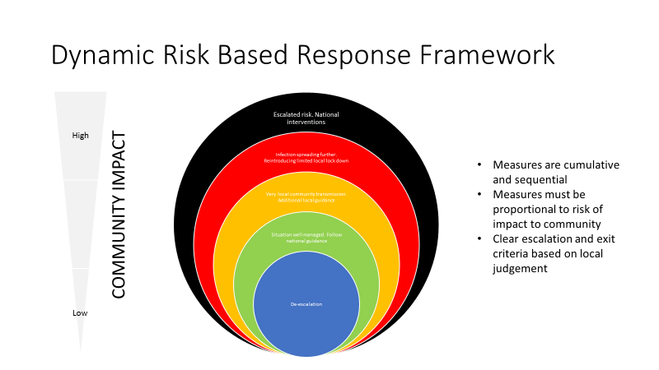

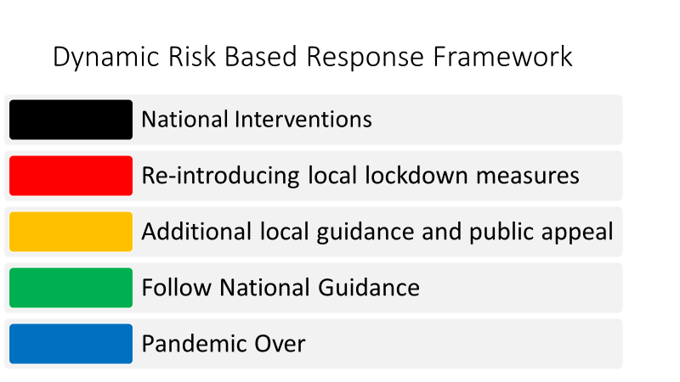
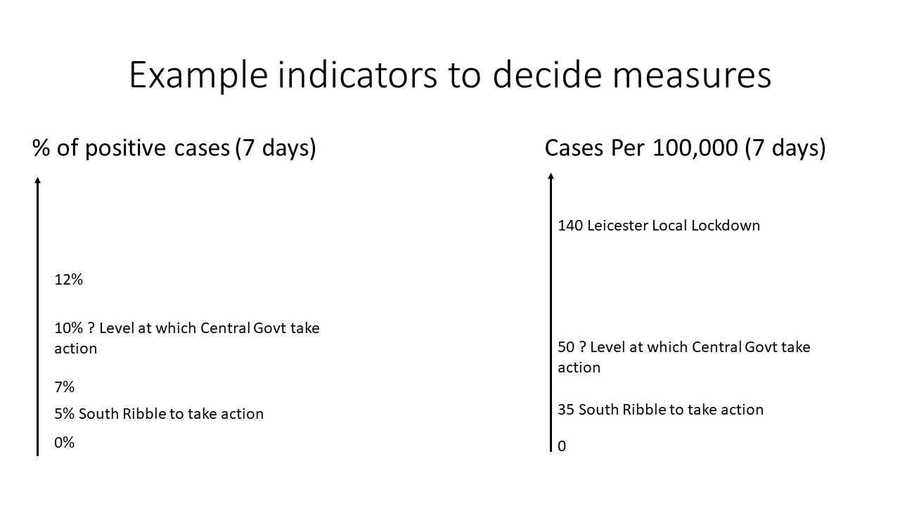

ANNEX C
Example Range of Interventions

This is not an exhaustive list but to demonstrate an escalation of measures from messaging to restrictions.

Messaging and reinforcing national guidance

- A media campaign to reinforce national guidance around handwashing, washing surfaces and social distancing to take place in the location and surrounding locations
- Encouraging communities to seek testing if they are symptomatic
- A targeted campaign within the specific location to enforce strict guidance including ceasing family gatherings, mixing groups outside direct household
- Targeted message campaigns for businesses or settings

Increased Testing and Inspections

- Deploying initial or additional MTU for symptomatic testing
- Opening MTUs for asymptomatic testing
- Organise language facilities at MTU sites
- Organise community swabbing teams to target specific settings
- Increase COVID secure inspections for businesses
- Increase licencing inspections for food and drink establishments

Restrictions

- Mandate facecovering in public
- Enforce social distancing in shops
- Restrict food and drink services indoors
- Closing transport hubs
- Stopping all gatherings
- Close education settings.

ANNEX D

Battle Rhythm for Triggering Task Force Activity and Declaring a Local Prevention Zone

ANNEX e
Lancashire County Council Covid-19 - Response and Containment offer

In the event of a localised outbreak of Covid 19 within Lancashire, Lancashire County Council (LCC) will support Adult Social Care Providers within care homes, supported living, domiciliary care and any other care settings.

In response to a localised outbreak, the county council will support activities to reduce the rate of infection, minimise sources of transmission and contain of specific outbreaks with the following actions;

LCC Customer Access Service – Adult Social Care single tel no.

 | Action | Owner/key contacts | Notes
1. | Facilitate/ assist with general communications re any future outbreak/local lockdown, government guidance for regulated care settings, the general public and relevant partners. |  | LCC will use its established COVID-19 communications channels to get key messages out to providers (provider portal, provider webinar, provider newsletter, and Contract Management targeted emails).  Information on localised outbreaks/lockdowns will be provided to the general public using the full range of LCC's corporate communication channels.  Targeted communications support will be available to individual homes/providers from LCC/NHS communications teams.
2. | Focused webinar; a specific webinar(s) for the dissemination of key messages, discussions and for providers to raise questions/concerns |  | All Providers to be invited to webinar and a recording of the session to be made available on the provider portal; frequency to be proportionate to the communications requirements.
3. | Work with Community Leaders to educate and share key messages |  | Via the Integrated Care System's VCFSE Leaders Alliance and LCC's Community Projects Team, LCC will share key messages (countywide networks should be aligned to local networks).
4. | Via LCC's Care Capacity Tracker, provide local intelligence from the outbreak dashboard and identify and escalate any risks to the appropriate body. |  | LCC conducts daily welfare calls to providers to collate and track important Covid-19 data to inform and support local planning and response and national reporting requirements. Information relating to transport/food/schools/childcare/medication/equipment issues will be captured via the calls and appropriate pathways followed.  This information is captured in performance dashboards which can be drilled down to district level intelligence.
5. | Support providers with testing (Test & Trace process/Repeat whole home/setting testing). |  | Established testing pathway in place for staff and people in receipt of care services which incorporates local arrangements.  Swabbing support offer to providers in place.  Support providers upon receipt of testing results to ensure appropriate infection, prevention and control measures are in place.  https://www.lancashire.gov.uk/practitioners/health-and-social-care/care-service-provider-engagement/coronavirus-covid-19-information-for-care-providers/covid-19-testing/
6. | Provide an Outbreak notification response pathway which will support providers in outbreak/lockdown. |  | We have established a seven day service with a central contact point for notification of cases and potential outbreaks from Public Health England. Notification will be through our dedicated email box COVID19-healthprotection@lancashire.gov.uk  This central contact and co-ordination point will be located within the County Council Public Health Team.  We expect the notification to mainly come from the national test and trace programme and PHE North West. Also through the daily tracker calls and the Outbreak dashboard.
7. | Provide support in the management of an outbreak |  | Lead and establish a Multi-Disciplinary Team response to wrap support around a provider in the event of an outbreak and develop an action plan (to include testing, staffing levels, PPE supplies, etc); as a crisis response.  LCC has an Outbreak Control Plan which details the processes and protocols in place should an outbreak occur.
8. | Provider Failure |  | Provider Failure Plan would be initiated and led on by LCC in the event of individual or multiple provider failure.  Implementation of the Plan will ensure continuity of safe/alternative care and support provision within the adult social care market.
9. | Provide Financial Support through LCC's Financial Assistance Programme and provide support/guidance with the Department of Health and Social Care Infection Control Fund. |  | Full details can be found here:  https://www.lancashire.gov.uk/practitioners/health-and-social-care/care-service-provider-engagement/coronavirus-covid-19-information-for-care-providers/financial-advice-and-support/
10. | Provide guidance on visitors to care homes (including families/trades/health professionals) |  | National guidance published (22 July); Kath is leading on the development of local guidance to be signed off by the LRF  https://www.gov.uk/government/publications/visiting-care-homes-during-coronavirus/update-on-policies-for-visiting-arrangements-in-care-homes
11. | Providing support with hospital admissions/readmissions & discharges. |  | Provider Escalation Team will dial in to the Local Regulated Care Cell/Outbreak Meetings with health to share intelligence around discharge/admission practice.  https://www.lancashire.gov.uk/media/917845/lancashire-resilience-forum-care-homes-admissions-policy-statement.pdf  LCC Teams for example, Care Navigation, have developed a number of discharge pathways.
12. | Support Providers with access to PPE supplies in the event of a supply chain shortage/failure |  | Established PPE pathway in place; currently Mon-Fri, 9-5pm via email/phone; could be stepped back up to include weekend and evening cover, if required
13. | Support workforce issues from the Lancashire Temporary Staffing Agency and the LCC Auxiliary/Emergency/Volunteer Workforce |  | To provide a short term paid resource to the sector in the event of staffing shortages and to minimise movement of staff between settings, reducing the reliance on agency staff and other staffing related issues.  Provide information and signposting to emotional/wellbeing support.  https://www.lancashire.gov.uk/practitioners/health-and-social-care/care-service-provider-engagement/coronavirus-covid-19-information-for-care-providers/workforce-training-and-recruitment-support/
14. | Provide information on end of life, hospice at home and bereavement support. |  | Provide information via the provider portal  https://www.lancashire.gov.uk/practitioners/health-and-social-care/care-service-provider-engagement/coronavirus-covid-19-information-for-care-providers/end-of-life-care/
15. | Provide information, guidance and support on Mental Capacity, Safeguarding/Deprivation of Liberty Safeguards/Best Interest Decisions and managing challenging behaviour and Dementia |  | Information and LCC Contacts available via the provider portal  https://www.lancashire.gov.uk/practitioners/health-and-social-care/care-service-provider-engagement/coronavirus-covid-19-information-for-care-providers/safeguarding-dols-mca-best-interest-and-dementia-advice/

ANNEX F
Mobilisation of testing units

There are plans to establish an MTU in the borough, and two locations have been identified Runshaw College and South Ribble Borough Council’s Civic Centre.

Should circumstances mean that community testing facilities are needed, the mobilisation will need to be finalised based on discussions with Lancashire County Council.

South Ribble Borough Council has available a number of physical assets across the borough that may provide suitable locations for testing units.

These potential locations have been selected based on the following assumed criteria:
- Easily accessible by road and public transport
- Close to any target communities (such as those with higher rates of infection rates, or a need to increase testing rates)
- Good car parking, including outside space for testing vehicles / circulation
- Covid-safe welfare facilities for staff

The potential locations in the borough include:
- Council community centres

